

**North Western University ,Khulna**

**Project Report**

**Course Title : Software Emgineering Lab**

**Course Code : CSE-** **3104**

**Project Name: Digital Prescription maker**

**Suabmitted To:**

**Name**: M. Raihan

Senior Lecturer

North Western University, Khulna

Submission Date : 08.04.2023

**Submitted by :**

Name : Sajib Tarafder

ID : 20211020010

Name : Rahul Biswas

ID : 20211003010

Name : Anuj Biswas

ID : 20211036010

Semester : 3rd Year $1^{st}$ Semester

Department of Computer Science and Engineering

North Western University ,Khulna

**Digital Prescription maker**

**Introduction:**

Our project title is “Online Prescription and Drug Management System” which is a web based application specially for efficient medicine distribution. The modern world is always accelerating forward and looking for various new methods in order to gain access to every form of freedom possible. The greatest form of freedom provided to man in the modern century is through use of the Internet for various tasks. And considering this as a great advantage a large number of people are now moving on to the Internet in order to get medicine or medication. Our aim is to propose a secure and safer Prescribing System that allows prescriptions’ authentication and protects the patient data, keeping their identity confidential.

**Problem Statements:**

All patients and pharmacists do not understand the doctor's handwriting properly. Many times the prescription is lost.

Statements of pharmacists about the problems they face on a

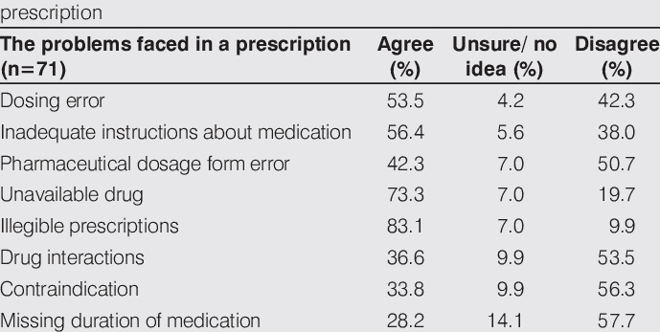

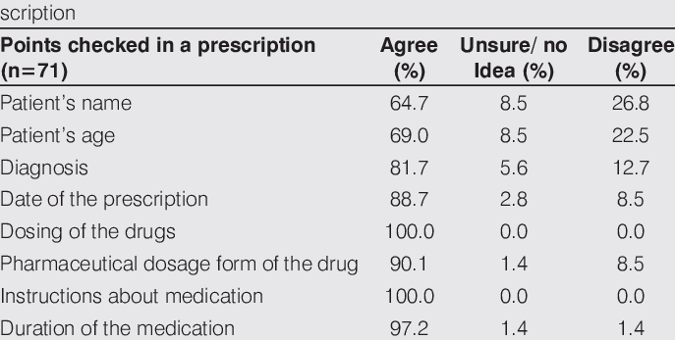

**Technologies:**

Frontend: HTML, CSS, BOOTSTRAP, JAVACSRIPT

Backend: PHP

Database: MySQL

**Software requirements**

Sublime text (Code editor)

XAMPP Sublime text

**Hardware requirements**

Internet accessible desktop or laptop Smartphone with any browser

**Requirement Collection and Analysis**

**Initial requirements**

Initial conditions we need to operate our system without this being difficult to execute. The following are provided

We need a database storage for web application

User device (computer/laptop or mobile)

Data validation requires some advance database query so that patient and doctor information

can be validated by each other.

**Admin requirements**

Admin performs the system's most significant job. His actions specifications and roles are set out below:

Administrators can monitor and act

Administrators can monitor and act

Solve problems faced by different users, doctors, pharmacy of the stage

Admin can add/ remove prescription Admin can add/remove doctor

Admin can add/remove patient

Admin can add/remove pharmacy

**User’s requirements**

The user can understand the details of the feature by using our systems. The following are their conditions:

They need any type of browser with a Smartphone / PC.

Need internet connection to check the prescription and search.

They need NID number to registrations

**Doctor requirements**

Doctor can easily prescribe the user by using our system. The following are their conditions

They need any type of browser with a smartphone / PC.

They need registered number to access

Need internet connection to see the prescription

**Dataflow:**

Why do we use our application use case model? We use case model in our project report so that by seeing that a non-technical person can also get an idea of what is happening and how the system's different functionalities work and interact with each other. Smoother project execution Build test instances System context specification.

**System**

**Add compounder**

Add patient

**E-R Data Model:**

Data Model Logical data model also called ERD by seeing that we can comprehend how all the information at the back end of the systems interact with each other. Since we are using XAMPP, we have a free and open-source web server, we have a lot of relationships with different database tables. Instead, we have unique object Id for each entry here, and these information are also formatted as JSON format. So, we can easily retrieve all the data from our collection

Hospital

Login

Admission

Appoinment

Diagnostic

Prescription

Advice

Report

prescription

admission

**Project Features:**

We are going to develop an online web application where doctor can provide prescriptions to the patient through online..The patient and the pharmacist can understand the prescription very easily.There will be no fear of losing the prescription.Throw our website user will be benefited in various sectors.

Wasting of time will be under control

Privacy of users will be so strong

User interface will be easy and efficient Proper medicine distribution

Medicine misusing will be so hard as admin can easily able to monitor whole system clearly.

**Target population:**

The digital prescription system has emerged to reduce the ambiguity and misunderstanding associated with handwritten prescriptions. The opportunities and challenges of e-prescription system, its impact on reducing medication error, and improving patient’s safety have been widely studied. However, not enough studies were conducted to explore and quantify the factors that affect rural patients’ compliance with digital prescription, especially from the perspective of Asian developing countries where most of the world’s population resides.

**Social-Economic Benefit:**

After successful development we believe that this concept will create a safe prescribing system that can be a good option for every smart citizen of our country. This distribution system can avoid misuse of medication because by this system no one can buy medicine without doctor registered prescription. Our main expectation from this projects is

Connecting all in one platform

Making communication easier

Saving time

Reduce risk of extra medication Misuse of medication.

We are working to connect doctors, patients and pharmacy to create a suitable environment in one platform so that the system will be much easier for patient to get proper medical prescription from doctor and collect it securely. This prescribing system can save users valuable time.

By using this management system we can assure that no person can buy medicine from pharmacy without doctor prescription. Without proper doctor provided prescription pharmacy can not see patients prescription and can not deliver the medicine. This system can reduce risk of extra medication for patient which is really bad for our health.

**GitHub ID:**

1.RahulBiswas4

2.SajibTarafder

3.anujb1998

**Github code & Commit :**

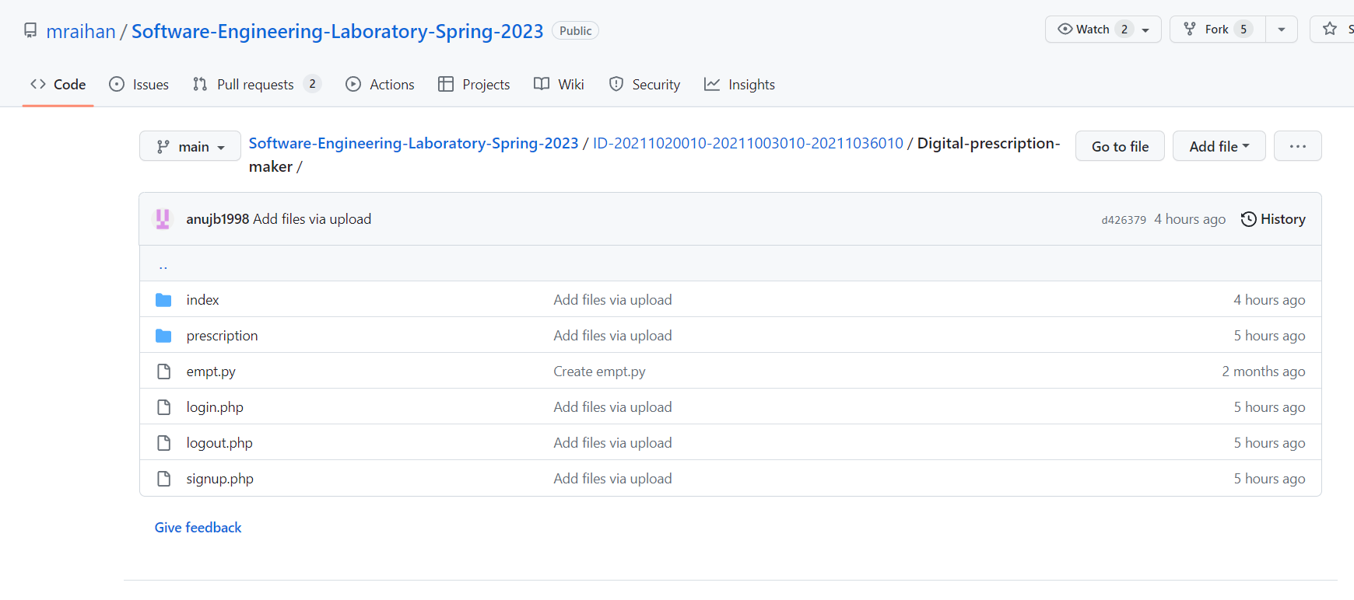

Project output:

Signup page:

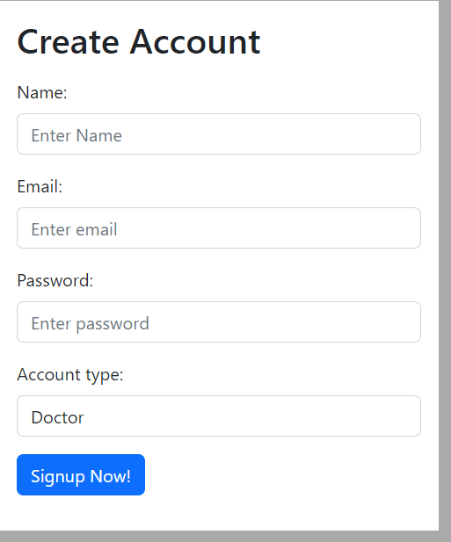

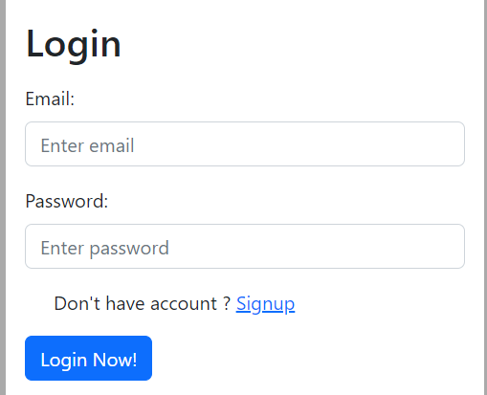

Home page:

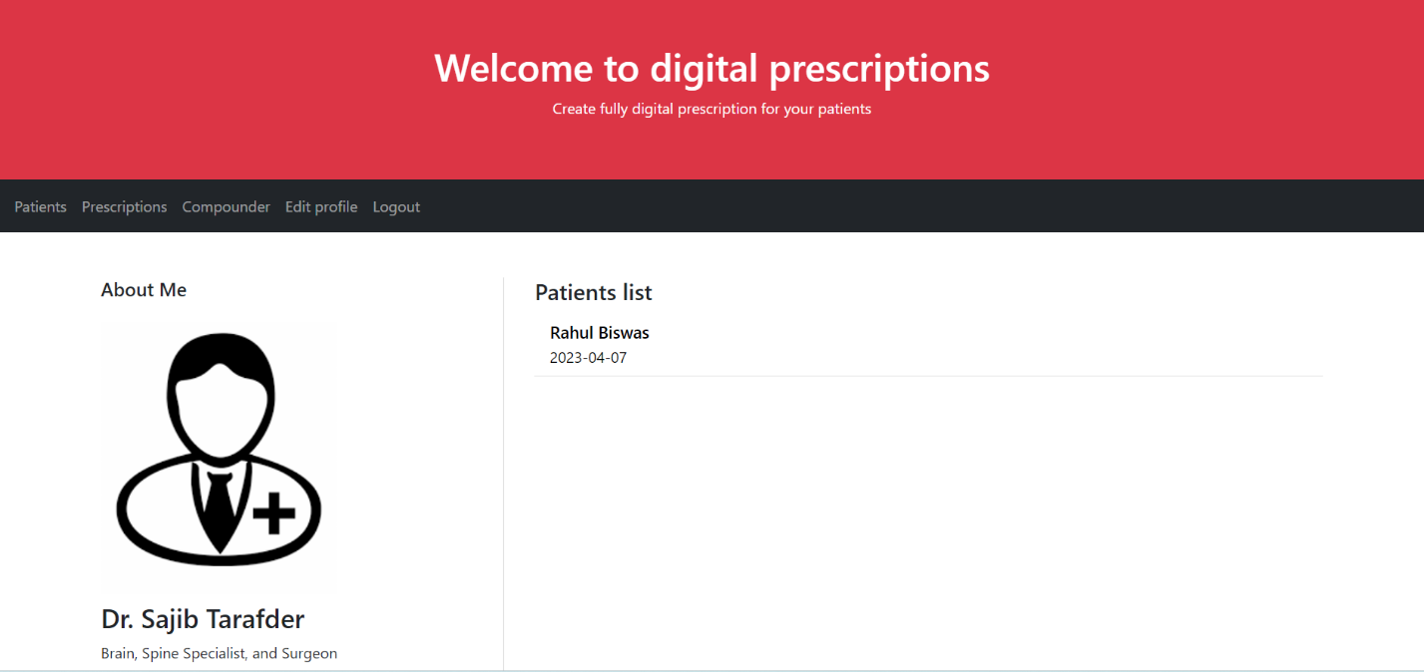

Doctor page:

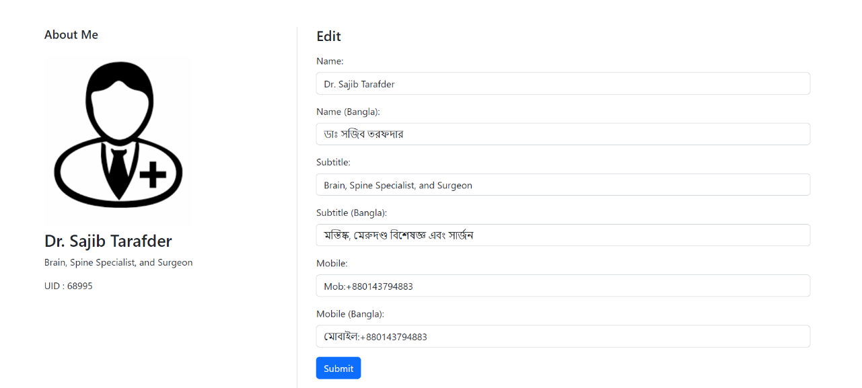

Compounder page:

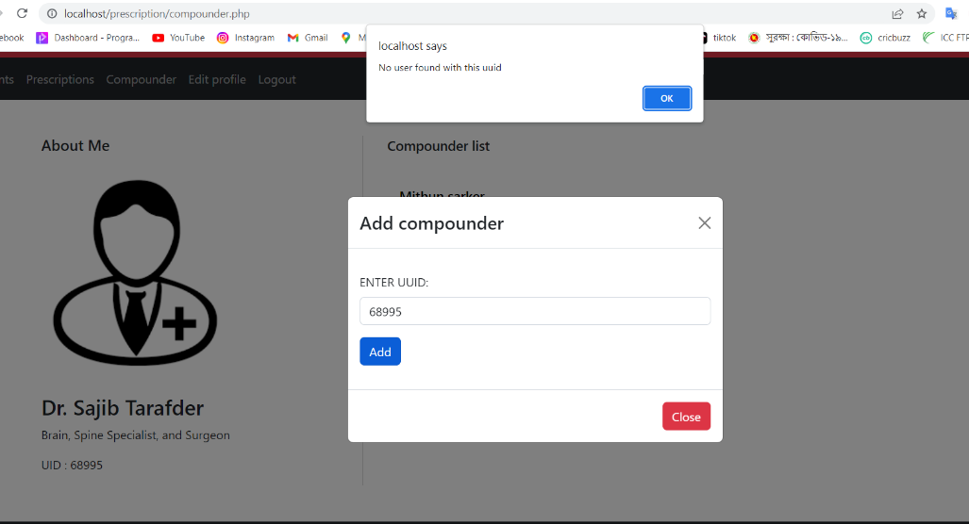

Add patient:

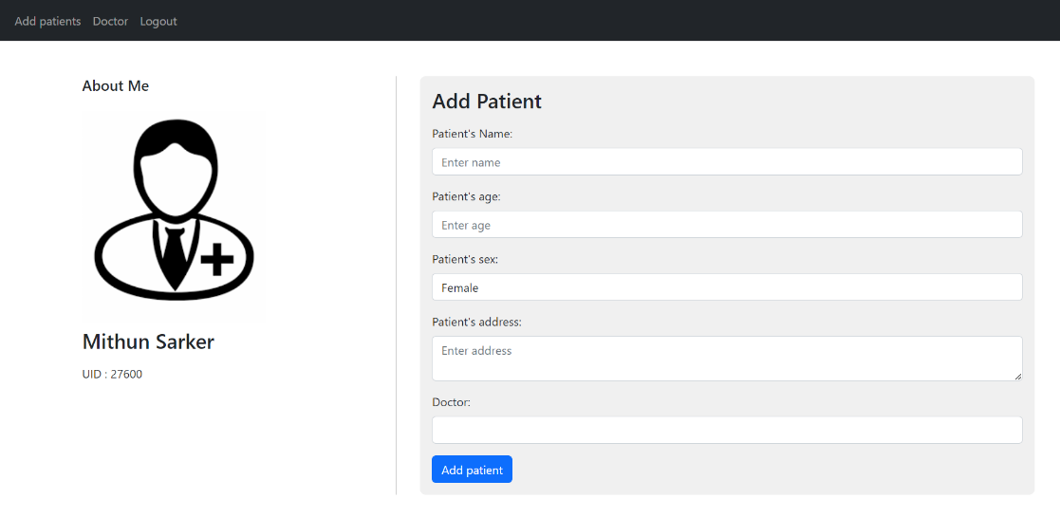

Prescription page:

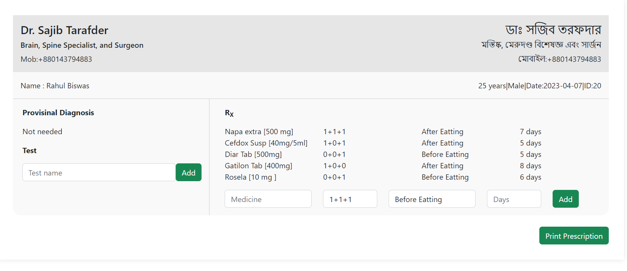

Prescription Print:

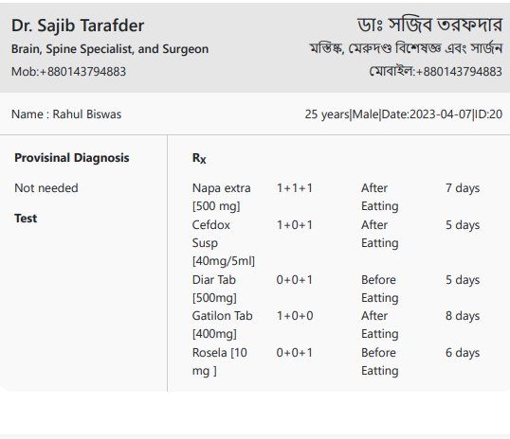

**Discussion and Conclusion:**

The main concept of this project is to ensure a secured platform for medicine user where there is no scope to misuse of proper medical treatment. People must need doctor permission to buy or use medicine when needed. This system is already used in many country around the world. But this type of prescribing system is not yet popular or well known in our country. But for our own health safety we need to use this drug management system properly. We believe that this project can help the people of our country because this type of medical distribution system is not using now-a-days. We are working to develop this platform and add more significant feature as soon as possible.

**References:**

[1] https://www.researchgate.net/figure/Statements-of-pharmacists-about-the-problems-they-face-on-a_tbl4_269830974 [accessed 7 Apr, 2023]

[2] https://github.com/

[3] https://www.share-netbangladesh.org/e-prescription-how-feasible-is-it-for-bangladesh/

[4] https://www.codeproject.com/